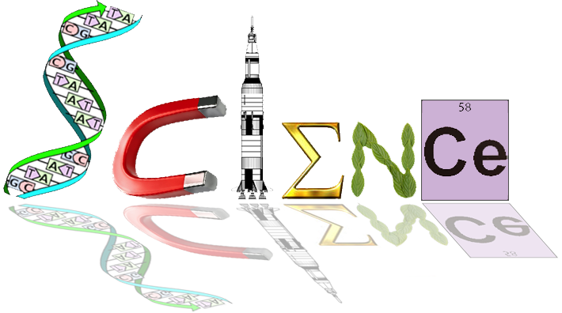

**Yr 12 ATAR Human Biology**

**Homeostasis**

**Test 2, Task 6**

**/55**

**Multiple Choice Section (17 marks)**

1. In a stimulus response feedback loop model, the environmental signal that alerts us is best described as the:

a) receptor

b) effector

c) response

d stimulus

2. Receptors involved in regulating our body temperature are called

a) photoreceptors because light is associated with heat

b) chemoreceptors

c) thermoreceptors

d) mechanoreceptors

3. Antidiuretic hormone is involved with which homeostatic mechanism?

a) body fluid composition

b) body temperature

c) blood sugar

d) blood pressure

4. Dr Smith is giving a series of lectures on homeostatic mechanisms found in the body that control certain outcomes. He has received a note from one of his students with four possibilities regarding the hormone and the process by which glucose molecules are chemically combined in long chains to form glycogen molecules. Which one is correct?

a) insulin and glucogenesis

b) insulin and glycogenolysis

c) insulin and gluconeogenesis

d) insulin and glycogenesis

5. A protein that has a central pore that allows ions, water, and other small molecules to pass from one side of a membrane to the other is called a

a) receptor protein

b) channel protein

c) carrier protein

d) cell marker protein

6. Aldosterone is a hormone found in the **adrenal medulla** which acts on the **liver** to increase the amount of sodium. The statement would be correct if some or all of the words in bold were replaced with these words:

a) adrenal cortex and kidney

b) kidney and decrease

c) adrenal cortex, kidney, decrease and potassium

d) adrenal cortex, kidney and decrease

7. Which of the following statements concerning the control of blood gases is correct.

a) the carbon dioxide concentration produces the most immediate effect  
b) the carotid and aortic bodies respond rapidly to the blood oxygen concentration.  
c) hydrogen ion receptors are found only in the carotid artery  
d) a more rapid rate of breathing is produced when the hydrogen ion concentration

increases.

8. In the control of blood pressure, which of the following is correct.  
  
a) in response to low blood pressure, sympathetic nerves from the cardiovascular

regulating centre of the medulla increase cardiac output.   
b) in response to high blood pressure, cardiac output increases with a decrease in stroke

volume and heart rate.  
c) in response to low blood pressure, parasympathetic nerves from the cardiovascular

regulating centre cause vasodilation  
d) in response to low blood pressure, nerve impulse from pressoreceptors in the medulla

increase.

9. After a meal of fish and chips with lots of salt which of the following would be true.  
  
a) More sodium would be present in the urine  
b) the secretion of aldosterone from the adrenal cortex would decrease.  
c) the secretion of adrenalin from the adrenal cortex would decrease  
d) both a and b above.

10. Negative feedback is where :  
  
a) the stimulus affects the response to reduce the response.  
b) the response affects the stimulus to reduce the stimulus  
c) the stimulus affects the response to increase the stimulus.  
d) the response is independent of the stimulus.

11. Homeostasis is   
  
a) the maintenance of a constant internal environment for the efficient functioning of

cells.  
b) the regulation of the composition of body fluids.  
c) the maintenance of a stable internal environment for the optimal functioning of cells.  
d) a regulated control of cell needs to provide for cellular respiration.

12. After a series of deep inhalations and exhalations (i.e. forced breathing) there is a period of reduced breathing rate because the:  
  
a) The nitrogen concentration of the blood has increased  
b) CO2 concentration of the blood has increased  
c) CO2 concentration of the blood has decreased  
d) O2 concentration of the blood has decreased.

13. After running hundreds of metres an athlete continues to breathe hard for some minutes because  
  
a) the high level of oxygen in the blood stimulates the cardiovascular centre to increase

the breathing rate  
b) the low level of bicarbonate ions in the blood stimulates receptors in the carotid and

aortic bodies to increase the breathing rate  
c) the high level of carbon dioxide in the blood stimulates the receptors in the medulla to

increase the breathing rate   
d) he needs to lower down the body temperature because of the excess heat

14. Which of the following is correct about the role of insulin, it…  
  
a) Stimulates cells to changes glucose to glycogen  
b) Stimulates cells to changes glycogen to glucose  
c) Slows down the oxidation of glucose by tissue cells  
d) Slows down the change of fats and proteins to glucose.

15. If a drug completely destroyed the cells of a man’s pancreas, we would expect to find a  
  
a) high concentration of glucose in his blood and in his urine  
b) normal concentration of glucose in his blood and a high concentration in his urine  
c) high concentration of glucose in his blood, but low concentration in his urine  
d) low concentration of glucose in both blood and urine.

16. Occasionally an individual is born without sweat glands. Such a person and a normal individual were placed in cool dry conditions and the skin and mouth temperatures recorded. The two persons were then placed in a moist hot environment and further recordings made. The results were as follows:

|  |  |  |  |  |
| --- | --- | --- | --- | --- |
|  | Skin temperature | Oral temperature | loss of H2O from  skin and lungs | Urine Volume |
| Cool Dry Atmosphere  Person X  Person Y | 33.9oC  32.7oC | 36.9oC  36.9oC | 5g  5g | Not recorded  Not recorded |
| Hot moist atmosphere  Person X  Person Y | 40.0oC  37.6oC | 38.6oC  37.0oC | 22 gm  262 gm | 270 ml  10 ml |

Select the correct statement from below.  
  
a) person X was born with sweat glands  
b) person Y was born without sweat glands  
c) person X was born without sweat glands   
d) person Y had more urine volume due to the presence of sweating.  
  
17. When glucose molecules are chemically combined in long chains to form glycogen

the process is known as

a) gluconeogenesis

b) glycogenolysis

c) respiration

d) glycogenesis

**Short Answer Section (33 Marks)**

1. (a) Name the labelled parts A, B, C, D, E, of the nephron below. (5 marks)

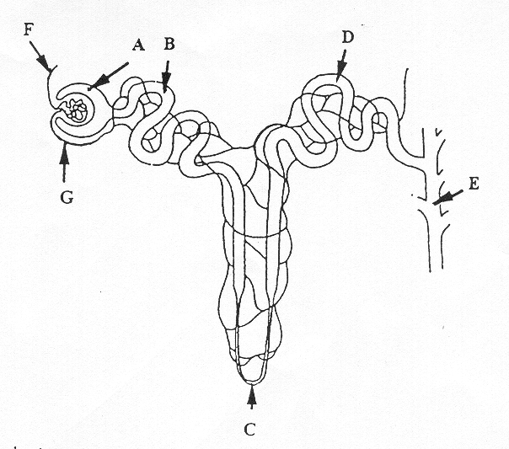

|  |  |
| --- | --- |
| **A** |  |
| **B** |  |
| **C** |  |
| **D** |  |
| **E** |  |

(b) Where does filtration occur, selective re-absorption and tubular secretion occur. (3 marks)

________________________________________________________________________________________________________________________________________________________________________________________________________________________

c) What hormone can affect this process? _______________________________________________ (1 mark)

2. The following questions refer to the graph below

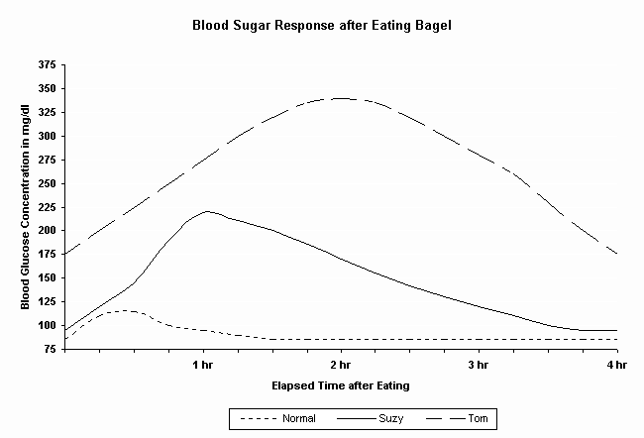

(a) Describe what happened to blood glucose concentration following the consumption of a bagel. (1 mark)

________________________________________________________________________________________________________________________________________________________________________________________________________________________

(b) Which hormone would be secreted during this time?

___________________________________ (1 mark)

(c) Describe how this hormone would achieve such an effect. (2 marks)

________________________________________________________________________________________________________________________________________________________________________________________________________________________

________________________________________________________________________________________________________________________________________________________________________________________________________________________

(d) How long does it take for the “Normal” blood sugar levels to maintain homeostasis?

________________________________ (1 mark)

(e) Both Suzy and Tom’s blood glucose concentrations are much higher than normal.

Suggest why this is so. (1 mark)

________________________________________________________________________________________________________________________________________________________________________________________________________________________

***Examine the graph below:***

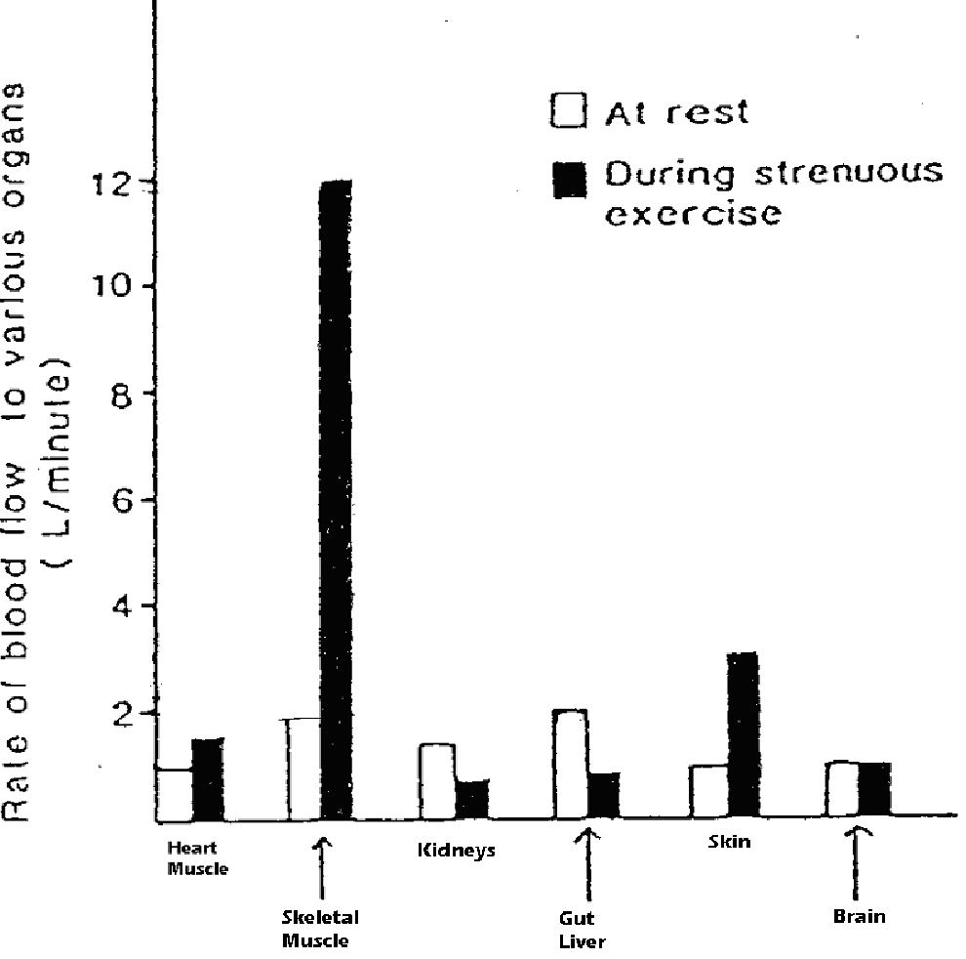

3. (a) What volume of blood flows to the gut and liver in 5 minutes when the body is at rest?

(1 mark)

_______________________________________________________________________________

(b) What is the percentage increase in blood flow to skeletal muscle between rest and strenuous exercise? (1 mark)

________________________________________________________________________________________________________________________________________________________________________________________________________________________

(c) Explain how the changed blood flow to the various organs between rest and strenuous exercise is achieved (ie how is the blood redirected). (2 marks)

________________________________________________________________________________________________________________________________________________________________________________________________________________________

(d) Explain why there is increased blood flow to the skin during strenuous exercise. (1 mark)

________________________________________________________________________________________________________________________________________________________________________________________________________________________

***The diagram, below shows how the hypothalamus regulates the secretion of thyroid hormones.***

***Use the diagram to help you complete the questions that follow.***

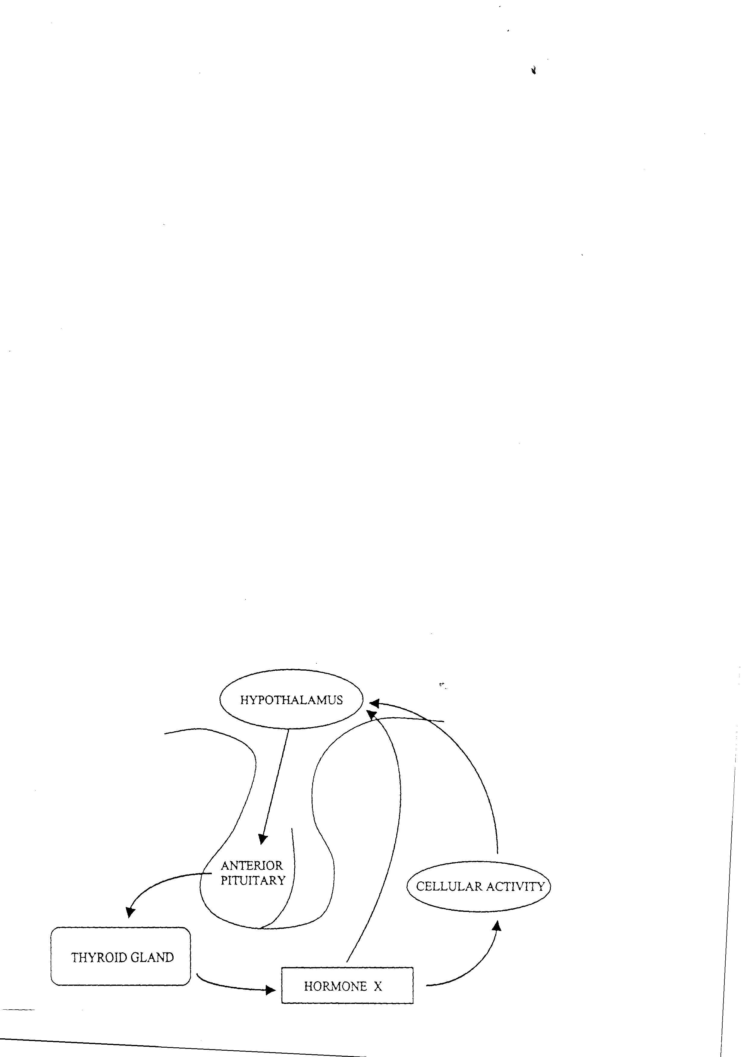

4. (a) Name two factors that stimulate the hypothalamus to initiate the control system.

1_____________________________________________________________

2 _____________________________________________________________ (2 marks)

(b) The hypothalamus responds by secreting ________________________________ that acts on the anterior pituitary to cause it to secrete__________________________________ (2 marks)

(c) What is the name of hormone X released from the thyroid gland?

___________________________________________________ (1 mark)

(d) List two ways the body responds to the release of hormone X.

1_____________________________________________________________

2 _____________________________________________________________ (2 marks)

5. (a) Explain why the cells of the body need to be maintained at a relatively steady temperature of 370C. (2 marks)

________________________________________________________________________________________________________________________________________________________________________________________________________________________

(b) **List** the ways in which the body tends to gain and lose heat (2 marks)

________________________________________________________________________________________________________________________________________________________________________________________________________________________

(c) What behavioural changes can we make to lower our core body temperature? (2 marks)

________________________________________________________________________________________________________________________________________________________________________________________________________________________

________________________________________________________________________________________________________________________________________________________________________________________________________________________

**Extended Answer Section (10 marks)**

**Select one only**

1. With the aid of a fully labelled flow diagram (e.g. stimulus-response model) describe the homeostatic regulation of blood and tissue fluid **water concentration**. Refer to the flow diagram in the course of your discussion.

**OR**

2. With the aid of a fully labelled flow diagram (eg stimulus –response model) describe the homeostatic mechanisms involved in the control of **blood sugar**. Refer to your flow diagram in the course of your discussion.

________________________________________________________________________________________________________________________________________________________________________________________________________________________________________________________________________________________________________________________________________________________________________________________________________________________________________________________________________________________________________________________________________________________________________________________________________________________________________________________________________________________________________________________________________________________________________________________________________________________________________________________________________________________________________________________________________________________________________________________________________________________________________________________________________________________________________________________________________________________________________________________________________________________________________________________________________________________________________________________________________________________________________________________________________________________________________________________________________________________________________________________________________________________________________________________________________________________________________________________________________________________________________________________________________________________________________________________________________________________________________________________________________________________________________________________________________________________________________________________________________________________________________________________________________________________________________________________________________________________________________________________________________________________________________________________________________________________________________________________________________________________________________________________________________________________________________________________________________________________________________________________________________________________________________________________________________________________________________________________________________________________________